Открытый урок по английскому языку в 7 классе по теме «Hobby».

Цель урока: активизация речемыслительной деятельности и навыков поискового чтения по теме «Хобби и увлечения», формирование благоприятных условий в рамках темы для развития самостоятельно мыслящей личности.
Задачи урока:
образовательные:
1) семантизация лексики по теме «Хобби и увлечения»;
совершенствование навыков поискового чтения с извлечением необходимой информации;
2) создание условий для формирования навыка устной речи в форме обсуждения и дискуссии;
3) развитие критического мышления.
развивающие:
1) развитие умения выказывать и аргументировать свою точку зрения;
2) развитие способности анализировать, сравнивать и систематизировать предлагаемый материал;
3) развитие способности к критическому мышлению.
воспитательные:
1) воспитание толерантности;
2) формирование умения работать в коллективе;
3) воспитание уважения к собеседнику.
Ход урока:
1. Орг. момент
Good morning, boys and girls (Good morning, teacher.)
- I am glad to see you. (We are glad to see you too,)
- How are you? (We are fine, thanks. And how are you?)
- I am fine, thank you. Who is absent today? (All pupils are present.)
- Sit down, please.
2. Фонетическая зарядка
Hickory, dickory, dock
The mouse ran up the clock.
The clock struck one,
The mouse ran down,
Hickory, dickory, dock.

3. «Мозговой штурм». Постановка познавательной задачи.
Look at the blackboard. How do you think what we will be discussing today? Can you predict the topic of our today’s lesson? (Ответы учеников.) You’re right. We’ll be discussing hobbies.
On the desk you see a piece of paper. Here you will write down your points.
Приложение 1
4. Речевая зарядка:
what do you like to do in your free time (Ответы учеников.)
what are you keen on?
What does the word hobby mean? (Ответы учеников.)
Hobby is an activity which somebody enjoys doing in somebody’s free time
Do you have a hobby? What is it?
Look at the blackboard. Make up the questions.
Приложение 2
1. What hobbies do you know?
2. What hobbies are popular in Russia?
5. What is your favourite hobby?
6. Do you enjoy travelling?
7. Are you fond of playing computer games?
8. What things do people usually collect?
9. Is collecting stamps interesting?
10. Do you go in for sport?
11. Is your hobby useful for you?
Lets Check. Write down your points.
The next task. Make up the dialogue.
Look at the blackboard. Remember the words. Read one by one and translate.
Good job.
Now match the pictures with their activities. Lets Check. Write down your points.
Приложение 3

5. Формирование навыков диалогической речи по теме «The world of Hobbies».
Учитель: Now you will work in pairs. Act out a conversation between two friends discussing their hobbies. Look at the screen.
For example:
- Do you like reading?
-Yes, I do\ No, I don’t.
- I like reading.
-I don’t like reading.
- And what about you? Do you like reading?
-I like reading, too\I don’t like reading, too.
6. Развитие коммуникативных умений учащихся в форме монологической речи.

Look at the blackboard. Do you know these people? What are they?
Guess the celebrities’ hobbies. Match the celebrities with the hobbies.
Ok. Let's check. Write down your points.

Учащиеся рассказывают об увлечениях известных людей (картинки с фото знаменитостей и их хобби).
Приложение 4

8. Закрепление лексического материала по теме «Hobbies» на основе двух упражнений по чтению.
Read the text and fill the missing words.
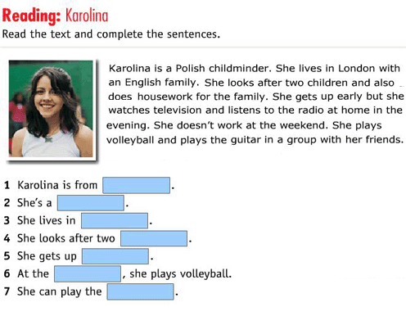
Check up. Write down your points.
Приложение 5
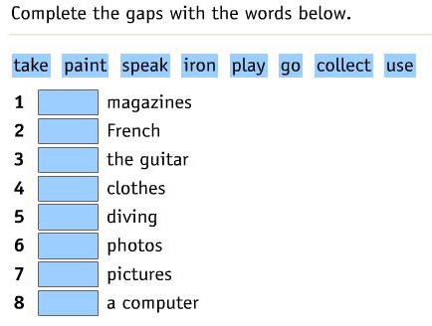
Check up. Read and translate one by one Write down your points.
9.Активизация навыков аудирования по теме “Hobbies”.
I think that you can easily guess the hobby. Let’s play the game “Guess the Hobby”.
Listen to me! Task № 1. What hobby is it? Write your answers in your tables.
1.Some people like to dance. Sometimes they go to the special clubs or dance at home. They like to go to a disco.
P: It is dancing.
.
2. Some people like to watch different kinds of programmes or films on TV. For example, children are usually fond of films about animals.
P: It is watching TV

3. Some people like to visit different cities, countries. They can travel by car, by plane, by train, by bus or on foot. This hobby helps them to learn history, geography and traditions of different people and countries.
P: It is travelling
Good job. Check up. Write down your points.

10. Now make up the word on topic «Hobbies. Good job. Check up.
Den-gar-ing | gardening
In-vell-tra | travelling
Sp-ts-or | sports
Lec-ting-col | collecting
Ad-re-ing | reading
Da-ing-nc | dancing
Sh-fi-ing | fishing
Ing-lk-wa | walking
Write down your points.
12.And the last task. Lets do the crossword.
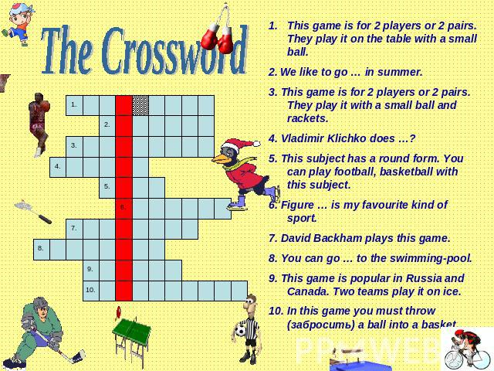
Lets check.Good job. Write down your points.

13. Итоги урока
We have a few time. Look at the presentation and tell about your hobby (дети рассказывают о своем хобби по образцу)
Lets count your points.
And here are your marks. All of you worked hard, actively and I noticed, with pleasure. All your marks are excellent and good. Your homework to write down about your work

